**PREMODEL EXAM CPP (HARI PRASAD S ,192221111)**

1.wirte a c++ program to implement a class called circle

that has private data memeber is radius

include a number function data member is radius of circle and circumference.

#include <iostream>

using namespace std;

class Circle {

private:

double radius;

public:

Circle() {

radius;

}

void set1(double r) {

radius = r;

}

double Circumference() {

return 2 * 3.14 * radius;

}

double area()

{

return 2* 3.14 * radius * radius;

}

};

int main() {

Circle C1;

double r;

cout << "Enter the radius of the circle: ";

cin >> r;

C1.set1(r);

double circumference = C1.Circumference();

cout << "The circumference of the circle is: " << circumference << endl;

double area=C1.area();

cout<<"the area of the square is:"<<area<<endl;

return 0;

}

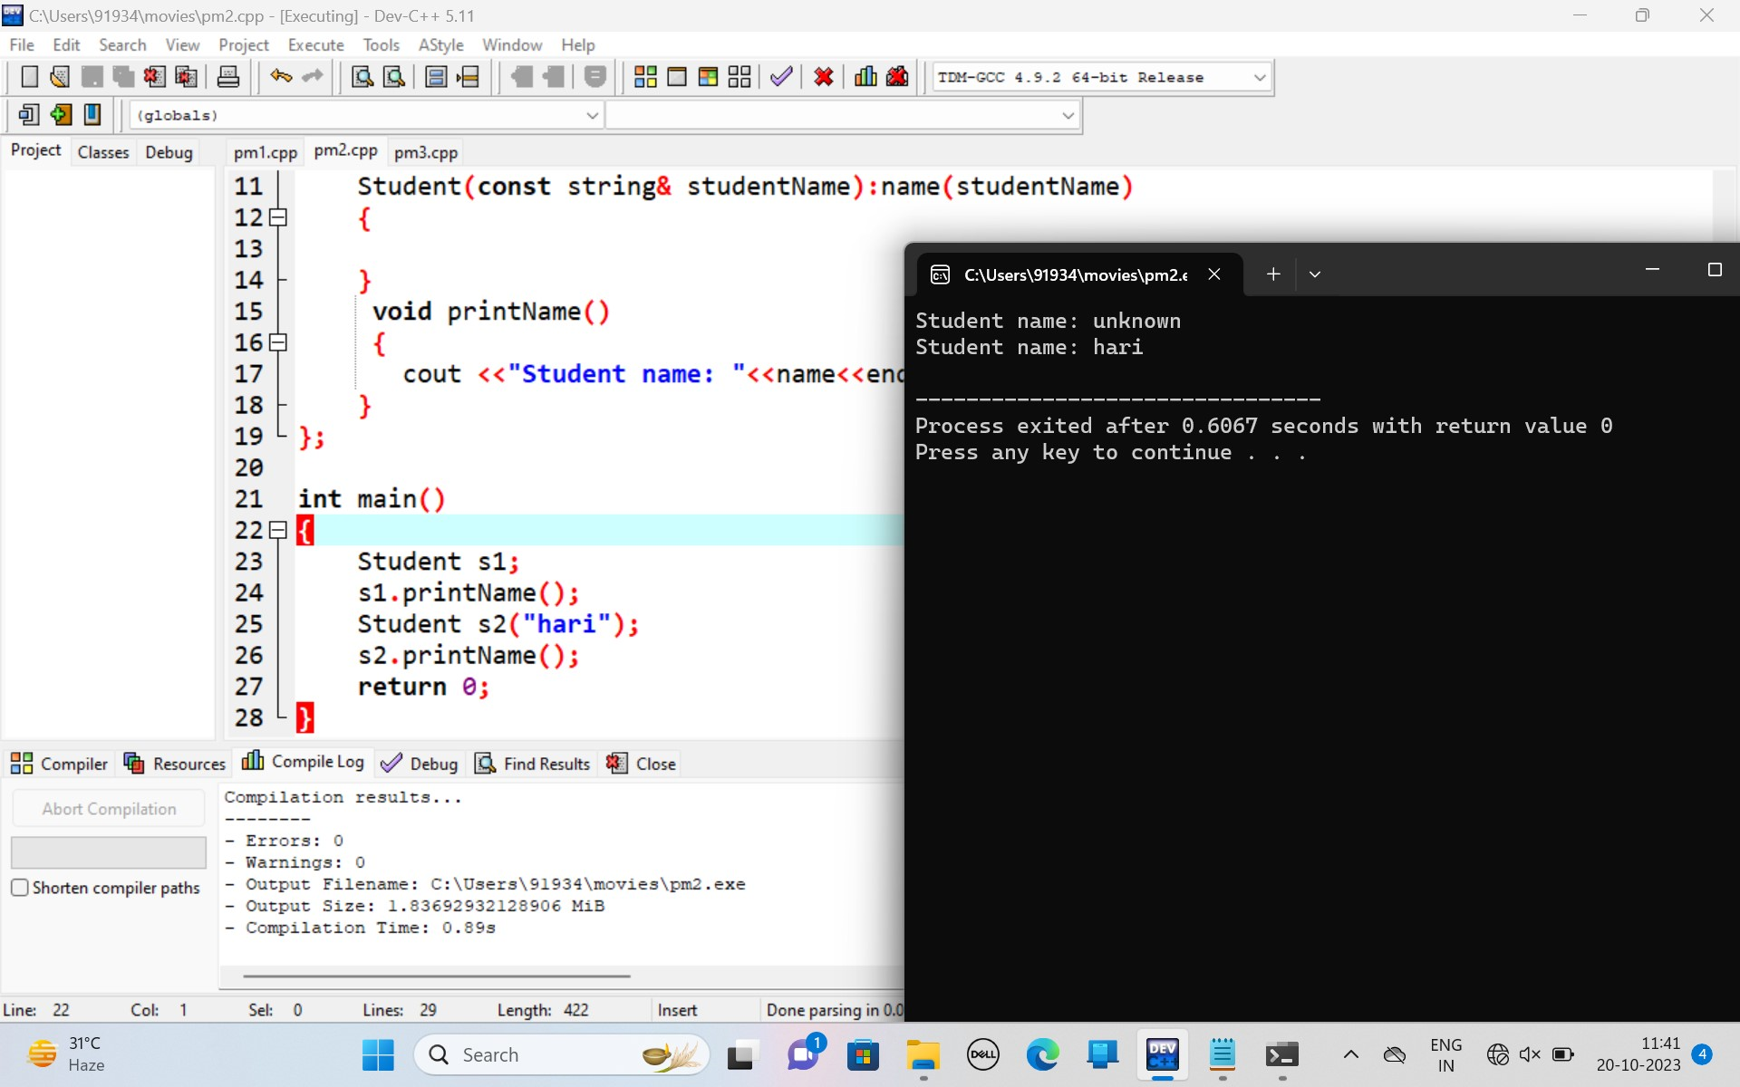

2.write a c++ program to print the name of the student by creating a student class if no name is passed while creating object of the student class print the student name is unknown and otherwise name should be equal to the string value passed by creating object passed.

#include <iostream>

using namespace std;

class Student

{

private:

string name;

public:

Student():name("unknown")

{

}

Student(const string& studentName):name(studentName)

{

}

void printName()

{

cout <<"Student name: "<<name<<endl;

}

};

int main()

{

Student s1;

s1.printName();

Student s2("hari");

s2.printName();

return 0;

}

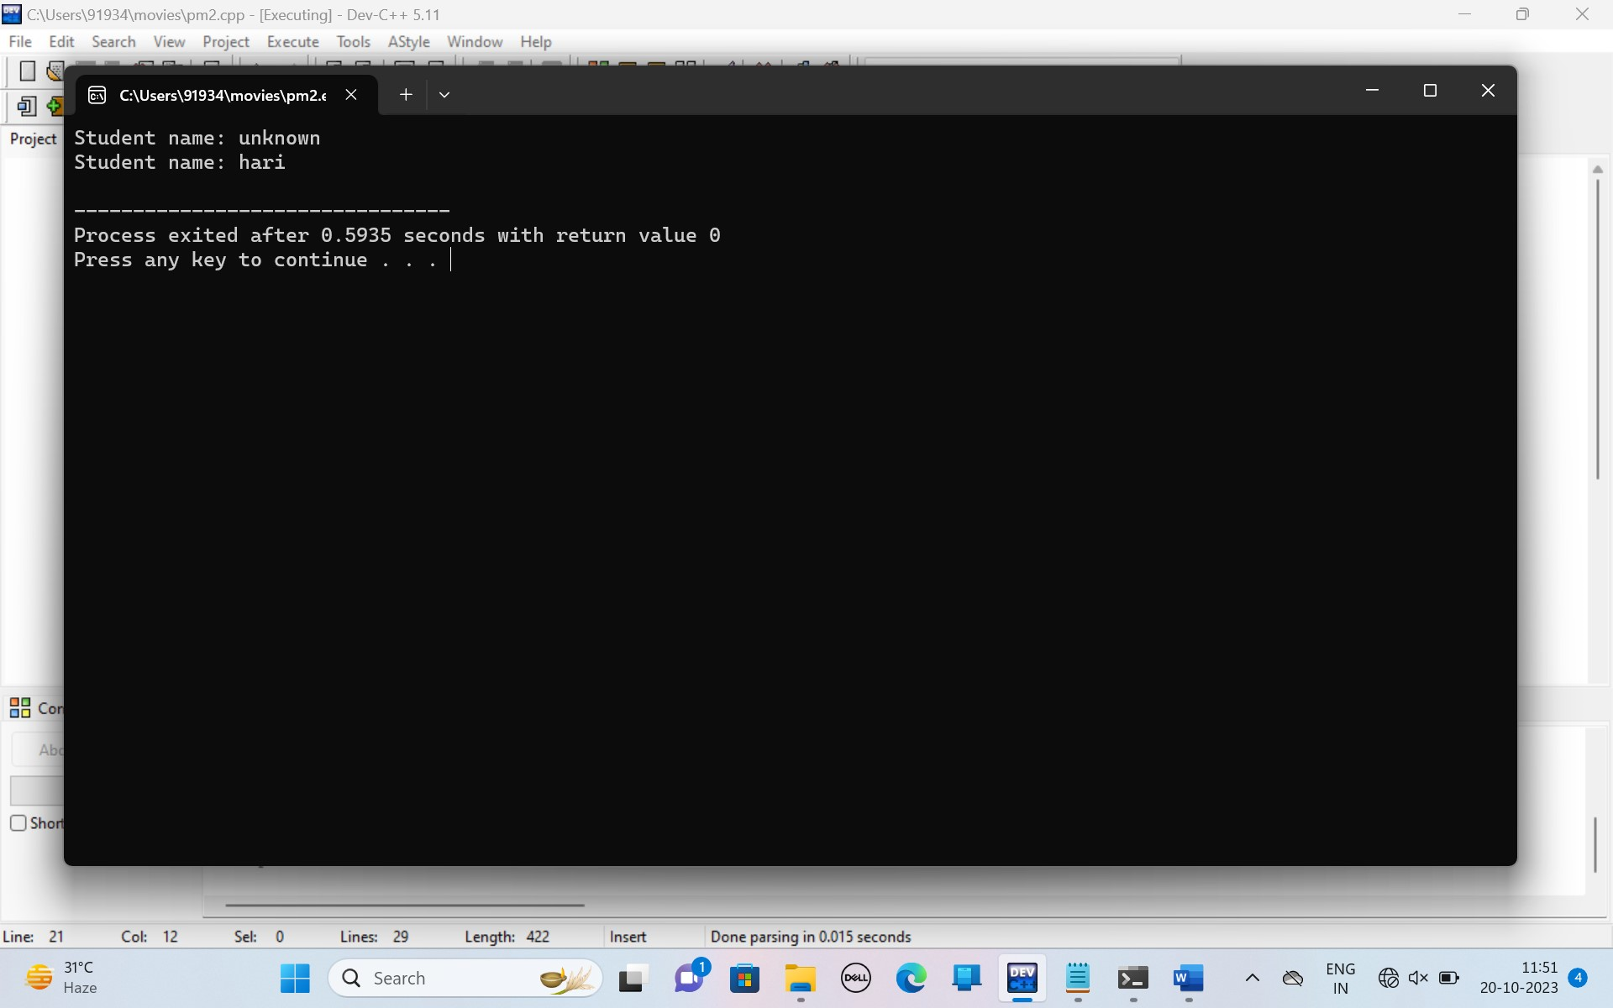

3.parttern for c++

1

123

12345

1234567

#include <iostream>

using namespace std;

int main()

{

int rows,i,j,k;

cout<< "Enter the number of rows: ";

cin >> rows;

for(i=1;i<=rows;i++)

{

for(j=1;j<=rows-i;j++)

{

cout << " ";

}

for(k=1;k<=2*i-1;k++)

{

cout<<k;

}

cout<<endl;

}

return 0;

}

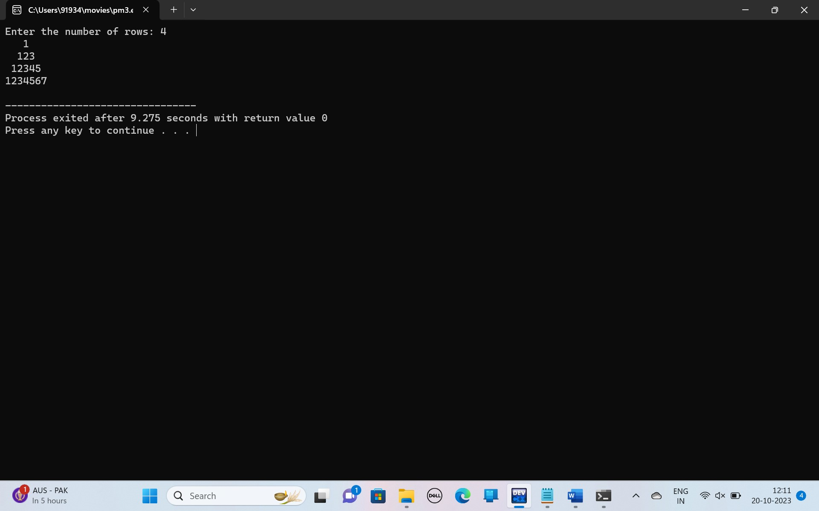

4.write a c++ program to implememt library to implement library system create a item class with title,author and publication year,intialize the data member using constructor(add any special data,version edition isbn)unconstructor and display all.

#include <iostream>

#include <string>

using namespace std;

class Item {

private:

string title;

string author;

int publicationYear;

public:

Item(const string& title, const string& author, int publicationYear)

{

this->title = title;

this->author = author;

this->publicationYear = publicationYear;

}

void display()

{

cout << "Title: " <<title<<endl;

cout << "Author: " << author << endl;

cout << "Publication Year: "<< publicationYear<<endl;

}

};

int main()

{

Item book("Sample Book", "John Doe", 2023);

cout << "Item Information:" <<endl;

book.display();

return 0;

}

